Ryan Helmlinger

Period 3

2/23/16

1. Original Image:



1. Sobel Line Recognition:

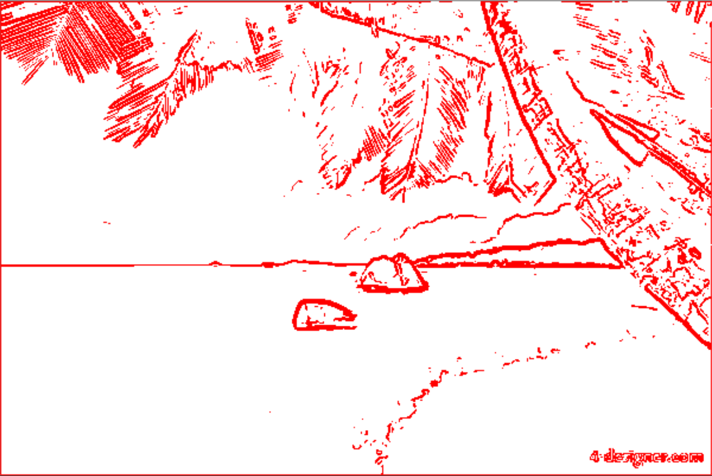

1. Canny Line Recognition:
   1. After edge thinning

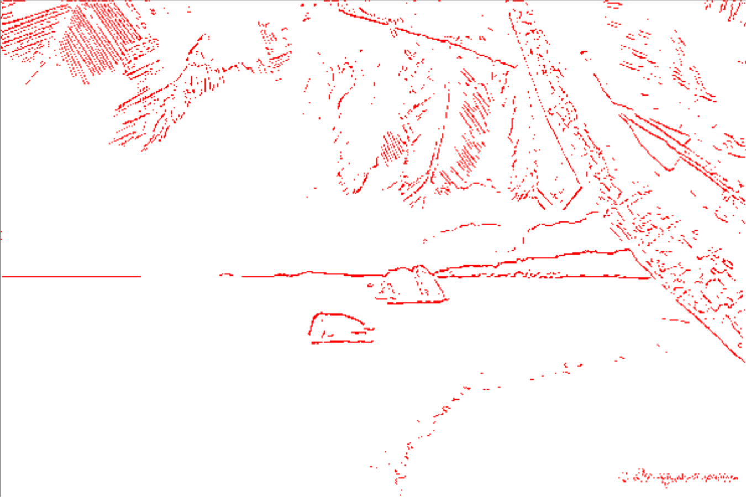

* 1. After weak edges are added:

